## Problem



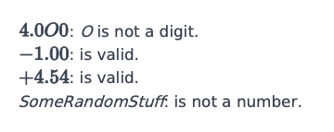

## Solution

# Enter your code here. Read input from STDIN. Print output to STDOUT

import re

for _ in range(int(input())):

    print(bool(re.match(r'^[-+]?[0-9]*\.[0-9]+$', input())))

## Explanation

Including the r in the regex = r means raw string.

we add r inside it to tell python to treat it as a raw string. print(r'\n)' == '\n' without r for ex : == print('\n')==newline this code is for python

^ says start of the expression.

[-+]? says it can start with either - or +.

[0-9] says any number from 0-9 can be followed after it.

* says that whichever thing it follows[in this case it is[0-9]], it can repeat arbitrarily times, even 0 times.

'.' is placeholder for any character.(for the answer it should be '\.' instead of '.' ; '\' is escape character. Because of this you can literally mean a dot in expression).

again[0-9] as explained earlier.

'+' says that whichever thing it follows[in this case it is[0-9]], it can repeat arbitrarily times, but atleast one time.

$ follows whichever thing it should come in the end.